Commitment to Community Foundation Donation Request Form
Thank you for your interest in the Commitment to Community Foundation and your request of a contribution to your charitable organization
The Commitment to Community Foundation is itself a non- profit organization, and we appreciate the importance of donations to support the work of community groups and organizations. While we cannot honor every request, we will carefully consider each request made.
*Please note that the requests should be submitted at least 1 week in advance
Your Name: _____________________________________________________________
Date of Request: ___________________ Date Donation is required: _______________
Is the organization a nonprofit 501C3? Yes_______ No________
What is the organization’s Tax I.D. Number: ____________________________________
Organization Web site (if applicable): __________________________________________
What is the purpose of the donation request? ___________________________________
_______________________________________________________________________
_______________________________________________________________________
_______________________________________________________________________
_______________________________________________________________________
Monetary Amount Requested: __________________
Make check payable to: _________________________________
Address to mail check: __________________________________
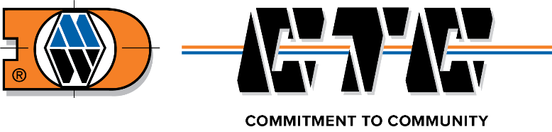
___________________________________________
___________________________________________
Phone Number: ______________________________
Please return completed donation request to CTCBOARD@DMWCC.COM

